**What is a Relational Database Management System?**

**Learn about RDBMS and the language used to access large datasets – SQL.**

**What is a Database?**

A *database* is a set of data stored in a computer. This data is usually structured in a way that makes the data easily accessible.

**What is a Relational Database?**

A *relational database* is a type of database. It uses a structure that allows us to identify and access data *in relation* to another piece of data in the database. Often, data in a relational database is organized into tables.

**Tables: Rows and Columns**

Tables can have hundreds, thousands, sometimes even millions of rows of data. These rows are often called *records*.

Tables can also have many *columns* of data. Columns are labeled with a descriptive name (say, **age** for example) and have a specific *data type*.

For example, a column called **age** may have a type of **INTEGER** (denoting the type of data it is meant to hold).

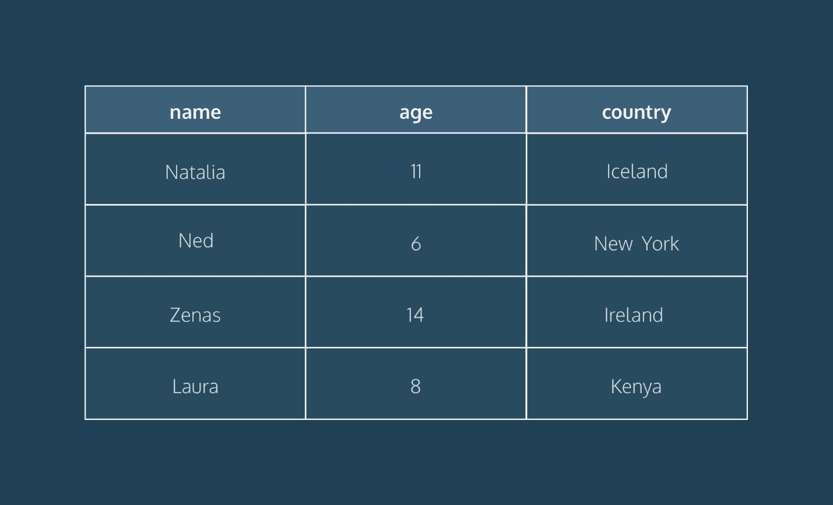

In the table above, there are three columns (**name**, **age**, and **country**).

The **name** and **country** columns store string data types, whereas **age** stores integer data types. The set of columns and data types make up the schema of this table.

The table also has four rows, or records, in it (one each for Natalia, Ned, Zenas, and Laura).

**What is a Relational Database Management System (RDBMS)?**

A relational database management system (RDBMS) is a program that allows you to create, update, and administer a relational database. Most relational database management systems use the SQL language to access the database.

**What is SQL?**

SQL (**S**tructured **Q**uery **L**anguage) is a programming language used to communicate with data stored in a relational database management system. SQL syntax is similar to the English language, which makes it relatively easy to write, read, and interpret.

Many RDBMSs use SQL (and variations of SQL) to access the data in tables. For example, SQLite is a relational database management system. SQLite contains a minimal set of SQL commands (which are the same across all RDBMSs). Other RDBMSs may use other variants.

(SQL is often pronounced in one of two ways. You can pronounce it by speaking each letter individually like “S-Q-L”, or pronounce it using the word “sequel”.)

**Popular Relational Database Management Systems**

SQL syntax may differ slightly depending on which RDBMS you are using. Here is a brief description of popular RDBMSs:

[**MySQL**](https://www.mysql.com/)

MySQL is the most popular open source SQL database. It is typically used for web application development, and often accessed using PHP.

The main advantages of MySQL are that it is easy to use, inexpensive, reliable (has been around since 1995), and has a large community of developers who can help answer questions.

Some of the disadvantages are that it has been known to suffer from poor performance when scaling, open source development has lagged since Oracle has taken control of MySQL, and it does not include some advanced features that developers may be used to.

[**PostgreSQL**](https://www.postgresql.org/)

PostgreSQL is an open source SQL database that is not controlled by any corporation. It is typically used for web application development.

PostgreSQL shares many of the same advantages of MySQL. It is easy to use, inexpensive, reliable and has a large community of developers. It also provides some additional features such as foreign key support without requiring complex configuration.

The main disadvantage of PostgreSQL is that it can be slower in performance than other databases such as MySQL. It is also slightly less popular than MySQL.

For more information about PostgreSQL including installation instructions, read [this](https://www.codecademy.com/paths/design-databases-with-postgresql/tracks/what-is-a-database/modules/using-postgresql-on-your-own-computer/articles/installing-and-using-postgresql-locally) article.

[**Oracle DB**](https://www.oracle.com/database/)

Oracle Corporation owns Oracle Database, and the code is not open sourced.

Oracle DB is for large applications, particularly in the banking industry. Most of the world’s top banks run Oracle applications because Oracle offers a powerful combination of technology and comprehensive, pre-integrated business applications, including essential functionality built specifically for banks.

The main disadvantage of using Oracle is that it is not free to use like its open source competitors and can be quite expensive.

[**SQL Server**](https://www.microsoft.com/en-us/sql-server/sql-server-2017)

Microsoft owns SQL Server. Like Oracle DB, the code is close sourced.

Large enterprise applications mostly use SQL Server.

Microsoft offers a free entry-level version called *Express* but can become very expensive as you scale your application.

[**SQLite**](https://www.sqlite.org/)

SQLite is a popular open source SQL database. It can store an entire database in a single file. One of the most significant advantages this provides is that all of the data can be stored locally without having to connect your database to a server.

SQLite is a popular choice for databases in cellphones, PDAs, MP3 players, set-top boxes, and other electronic gadgets. The SQL courses on Codecademy use SQLite.

For more info on SQLite, including installation instructions, read [this](https://www.codecademy.com/courses/learn-sql/articles/what-is-sqlite) article.

**Using An RDBMS On Codecademy**

On Codecademy, we use both SQLite and PostgreSQL. While this may sound confusing, don’t worry! We want to stress that the basic syntax you will learn can be used in both systems. For example, the syntax to create tables, insert data into those tables, and retrieve data from those tables are all identical. That’s one of the nice parts of learning SQL — by learning the fundamentals with one RDBMS, you can easily begin work in another.

That being said, let’s take a look at some of the more subtle details:

* *File extensions* — when working with databases on Codecademy, take a look at the name of the file you’re writing in. If your file ends in **.sqlite**, you’re using a SQLite database. If your file ends in **.sql**, you’re working with PostgreSQL.
* *Data types* — You’ll learn about data types very early into learning a RDBMS. One thing to note is that SQLite and PostgreSQL have slightly different data types. For example, if you want to store text in a SQLite database, you’ll use the **TEXT** data type. If you’re working with PostgreSQL, you have many more options. You could use **varchar(n)**, **char(n)**, or **text**. Each type has its own subtle differences. This is a good example of PostgreSQL being slightly more robust than SQLite, but the core concepts remaining the same.
* *Built-in tables* — As you work your way through more complicated lessons on databases, you’ll start to learn how to access built-in tables. For example, if you take our lesson on indexes, you’ll learn how to look at the table that the system automatically creates to keep track of what indexes exist. Depending on which RDBMS system you are using (in that lesson we’re using PostgreSQL), the syntax for doing that will be different. Any time you’re writing SQL about the database itself, rather than the data, that syntax will likely be unique to the RDBMS you’re using.

**Conclusion**

Relational databases store data in tables. Tables can grow large and have a multitude of columns and records. Relational database management systems (RDBMSs) use SQL (and variants of SQL) to manage the data in these large tables. The RDBMS you use is your choice and depends on the complexity of your application.